Design and Development of A Vertical Wind Turbine Using Slow Wind Speed for Mini Power Generation

Abdul Talib Din¹, Shamsul Bahari Azraai², Kesavan Thenamirtham³

1), 2) & 3) Faculty of Mechanical Engineering, Universiti Teknikal Malaysia Melaka, Ayer Keroh, 75450 Hang Tuah Jaya, Melaka, Malaysia

_____________________________________________________________________________

Abstract

Wind energy can be changed into other forms of energy, either mechanical or electrical energy. To convert the kinetic energy into electricity, the wind turbines, which consists rotor blades, shaft and electricity generator is needed. Rotor blade is the most important part because when the wind forces the blades to move, it will transfer most of its energy to the rotor. Then the rotor transfers its mechanical, rotational energy to the shaft, whereby it is connected to the center of the rotor before enters an electrical generator on the other end. The aim of this study is to investigate the possibility of improving wind energy capture, under low wind speed conditions using various blade configurations. This paper deals with the results of the first part of the study which is the development of the methodology using physical test rig and computer modeling using commercial computational fluid dynamics (CFD) code. This study focuses mainly on analyzing the efficiency of the energy conversion and torque coefficients in relation to the tip speed ratio of wind turbine. For the overall performance, the results show that the output power produced by the wind turbine has great potential to be used in the slow wind region in the range of 5 to 10 km/hr.

- Introduction

Wind energy, also called wind power, refers to the process by which wind is used to generate mechanical power or electricity. Wind can be used to do work. The kinetic energy of the wind can be changed into other forms of energy, either mechanical energy or electrical energy. Wind is actually a form of solar energy because the uneven heating of the atmosphere by the sun, the irregularities of the earth’s terrain, bodies of water, and vegetative cover. This wind flow, or motion energy, is then used by wind turbines to generate electricity [1].

Today, wind turbines have to compete with many other energy sources. It is therefore important that they be cost effective. They need to meet any load requirements and produce energy at a minimum cost per dollar of investment. Performance characteristics such as power output versus wind speed or versus rotor angular velocity must be optimized in order to compete with other energy sources. Yearly energy production and its variation with annual wind statistics must be well known. The shaft torque must be known so the shaft can be built with adequate strength and the turbine load properly sized [2].

- Research Methodology

  - Concept generation

Firstly the literature review gave a basic knowledge or ideas to the project. From that a proper and suitable tool is chosen to complete the project. The measurement of the retractor to be designed is done

in this analytical stage. Once the measurement have been taken, the design of the retractor is carried out before it can be fabricated into a prototype. Two types of tools selected are hardware and software tools.

Upon identifying the suitable wind turbine limitations, several concept designs were studied for selecting the best concept. The objectives are achieved by comparing and redesigning again and again the existing design in the market by means of two separate methods. However these two methods are implemented in parallel and often related with each other to generate possible and viable concept and further developed the conceptual design. These two methods are:-

- Analytical Method
- Graphical Method

2.1.1 Analytical Method

Analytical method is by using theoretical calculation using wind kinetic energy formula while Graphical method is by using CFD to see the pressure distribution on the propeller blade.

Kinetic energy formula:

P_{w} = ½ ρϑ³ A = P_{w} = ½ mV²

Power Coefficient formula:

P_{ex} = C_{p} ½ ρAV³ for practical wind turbine, the usual range of C_{p} is in the range of 0 ≤ C_{p} ≤ 0.4

Torque Formula:

T_{t} = { P_{ex}[2] }/ w_{t}

2.1.2 Graphical Method

This method is mainly illustration based. As for this project, the graphical representation of the wind turbine is by using computer aided design drawing. The 3 D or solid modeling done by SOLIDWORK cad software for superior part and assembly modeling, drafting, transparent data management and built in finite element analysis.

2.2 Engineering Analysis

Computational Fluid Dynamic (CFD) is one of the branches of fluid mechanics that uses numerical methods and algorithms to solve and analyze problems that involved fluid flows. Computer are used to performed calculation required to simulate interaction of liquid and gas with surfaces defined by boundary conditions. The software used to perform this task is ANSYS FLUENT Flow Modeling Software.

- Literature Review

Wind energy is in reality a by product of solar energy. The sun emits radiation which tends to heat parts of the globe at different rates and this difference is most notably during the day and night, but it occurs also when different surfaces for example, water and land absorb or reflect heat at different rates. This in turn causes portions of the atmosphere to warm differently. Due to this temperature and pressure variance, hot

air rises reducing the atmospheric pressure at the earth's surface and cooler air is drawn in to replace it, this results in wind formation.[1][2]

An energy system does exactly that, wind energy system transforms the kinetic energy of the wind into mechanical or electrical energy which can be harnessed for practical use. Mechanical energy is most commonly used for pumping water, also be used for many other purposes for example grinding grain, sawing, pushing a sailboat, and etc in rural or remote locations. Wind electric turbines on the other hand are used to generate electricity for homes and businesses.

There are two basic designs of wind electric turbines: vertical-axis and horizontal-axis machines. Horizontal-axis wind turbines are most common today, constituting nearly all of the utility-scale turbines in the global market, from 100 kilowatts, kW, capacity and larger.[3]

Beginning since the 7th century AD, humans have harnessed the wind to grind grain, pump water, and more recently to generate electricity, due to the rise of power demands globally and the soaring price of fossil fuel to generate electricity.

The energy that is contained in the wind is dependent on three factors [9]:

- the density of the air,
- the cross-sectional area the wind blows through,
- Speed/velocity of the wind.

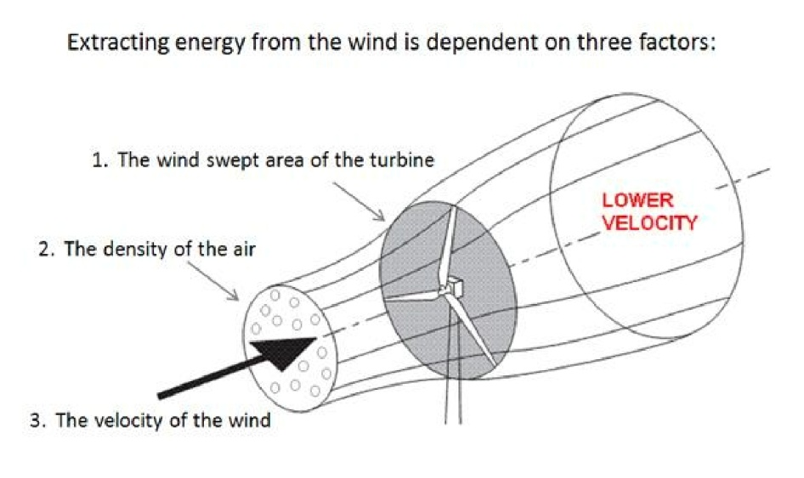

Figure2.1: Three factors of extracting wind energy. (Source: http://www.alternative-energy-news.info/)

As each one of these factors increases, so does the energy stored in the wind. The reason that the wind velocity is an important factor is because the energy increases as a cube (x³)of the wind velocity, meaning that if the wind speed doubles then the energy increases by a factor of eight.

In order to capture this energy and convert it to electrical energy, one needs to have a device that is capable of ‘touching’ the wind. This device, or turbine, is usually composed of three major parts: the ‘blades’, the drive train, and the generator. The blades are the part of the turbine that touches the wind and rotates about an axis. The drive train connects the rotating blades to the generator, and the generator converts the mechanical energy into electrical energy. The blades can be based on a lift principle (similar to aircraft wings) or a drag principle (similar to a boat sail). Traditional 3-bladed propeller-type wind turbines are lift machines, for instance. The drive train exists so that the mechanical energy created by the blades can be transferred to the generator. Sometimes the drive train can be used to increase the speed of rotation, dependent on the generator that is used. The generator then passes wire through an electromagnetic field, which creates current flow. This current is then converted to a form that is usable by everyday electrical devices. [3][6]

The design of the turbine determines how much of the energy from the wind can be extracted. Albert Betz, a German physicist, determined that the most energy that any device can extract is 59% of the total energy contained in the wind. He derived an equation called the Betz Law that tells how much of the energy from the wind that can be extracted ^{[4]}. Based on this equation, wind turbine designers can only manipulate two factors: the efficiency of the turbine blades called the Coefficient of Performance, or Cp and the wind-swept area or cross-sectional area. The higher these values are, the more energy that can be extracted from the wind, and as a drawback there will be mechanical and electrical losses due to friction and heat.

- Findings

From the simulation carried out, values of pressure, velocity and turbulence are obtained. These values form flow analysis are then separated into:-

- Minimum pressure and maximum pressure
- Minimum and maximum velocity
- Minimum and maximum turbulence

These minimum and maximum values are then tabulated according to the concept design that the value correspond to. The results are tabulated as follows:-

No. of Blade | Radius from center of turbine (mm) | Min Pressure  (Pa) | Max Pressure (Pa) | Min Velocity  (m/s) | Max Velocity  (m/s) | Min Turbulence (m²/s²) | Max Turbulence (m²/s²)
2 | 1300 | -87.711 | 23.783 | 0.1121 | 3.529 | 0.0399 | 5.2508
 | 1400 | -64.785 | 23.763 | 0.0847 | 3.309 | 0.0394 | 5.1393
 | 1500 | -55.571 | 29.468 | 0.0713 | 3.239 | 0.0403 | 5.0853
3 | 1300 | -109.557 | 28.663 | 0.0 | 4.278 | 0.0046 | 5.8298
 | 1400 | -57.262 | 23.686 | 0.0849 | 3.629 | 0.0281 | 5.3464
 | 1500 | -54.798 | 23.453 | 0.0348 | 3.277 | 0.0357 | 4.6544
4 | 1300 | -138.769 | 30.775 | 0.0465 | 4.623 | 0.0304 | 6.2953
 | 1400 | -63.484 | 23.347 | 0.0727 | 3.733 | 0.0306 | 6.1934
 | 1500 | -53.918 | 22.051 | 0.0369 | 3.357 | 0.0328 | 5.9162

The graphical sample results for 2 blade surface pressure simulation are as follows:-

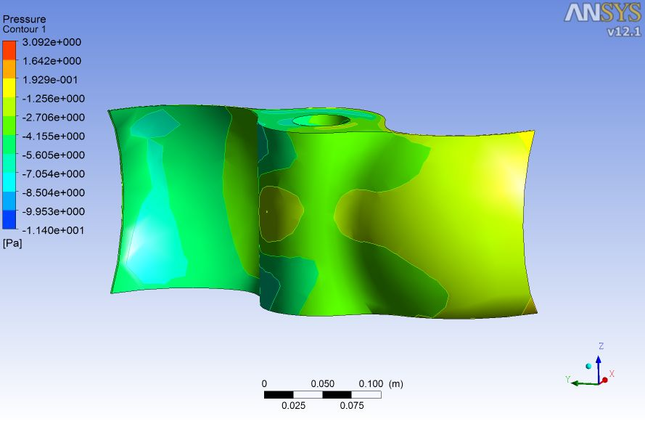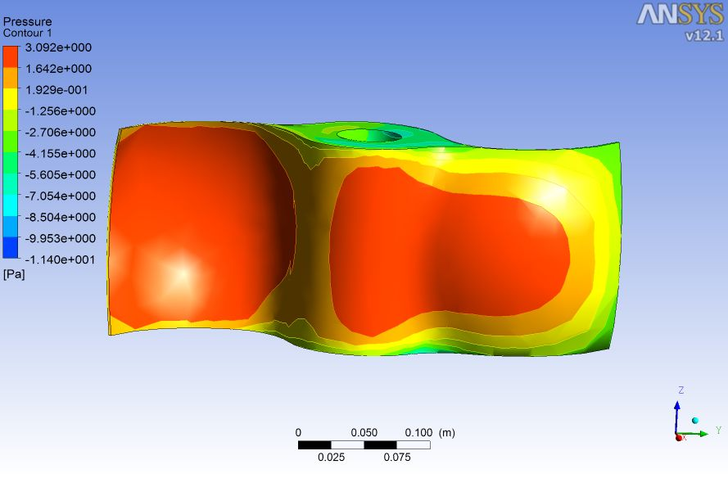

The graphical sample result for 2 blade velocity simulation are as follows:-

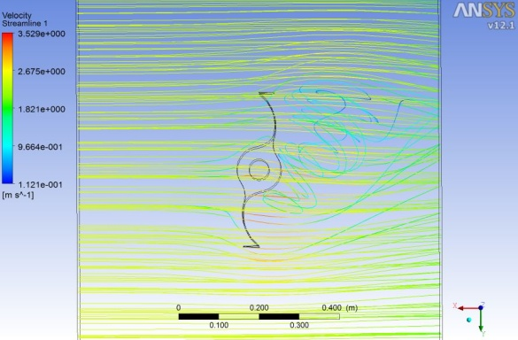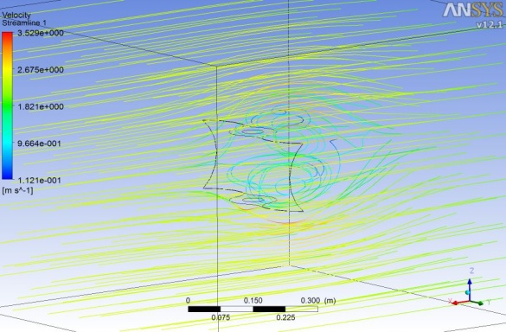

The graphical sample result for 2 blade turbulence simulation are as follow:-

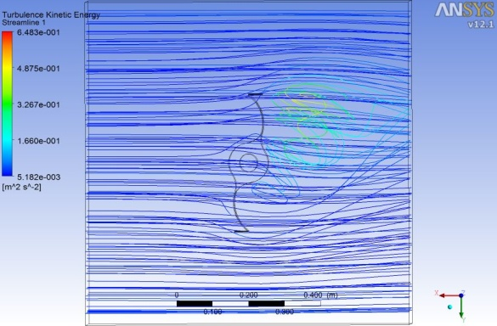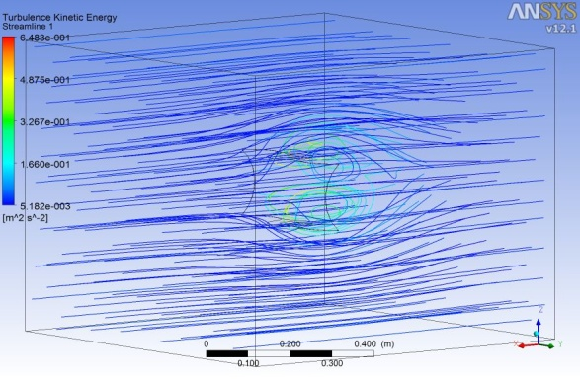

- Conclusion

From the results obtained it is found the the design can work for the slow speed range of wind of about 2.5 to 2.9 m/s. This mean that the research has achieved its importance objectives to design a wind turbine that can work in the slow wind speed zone like Malaysia. It is found that wind turbine of 2 blade design with 2,461.54 diameter is more acceptable as it has the optimum performance. This design has the performance Coefficient C_{p} of 0.324 which is in the best range of 0 to 0.4. The design is further endorsed by it tip speed ratio of 0.9967. The selected wind turbine is calculated to harness 8.8824 watt of power from the wind at 2.5 m/s speed with the maximum power of 24.4148 watts at 2.9 m/s wind speed.

- References

[1] Letcher, T.M. (Eds.)(2008). Future Energy: Improved , sustainable and clean option for our planet. Amsterdam: Elsevier

[2] E.P. Chiang, Z. A. Zainal, P.A. Aswata Narayana, K.N. Seetharamu (2000). Potential
Of renewable wave and offshore wind energy sources in Malaysia

[3] Pope., K. Dincer, I. Naterer, G.F. (2010). Renewable energy: Energy and exergy comparison of horizontal axis and vertical axis wind turbine. Elsevier

[4] Martinio Marini, Aristide Massardo and Antonio Satta (1992). Performance of vertical axis wind turbine with different shapes. Journal of Wind Engineering and aerodynamics.

[5] Pope, K. Rodrigues, V. Doyle, R. Tsoplas, A. Gravelsins, R. Naterer, G.F. Tsang, E. (2010). Renewable Energy: Effect of Stator vane on power coefficient of a zephyr vertical axis wind turbine. Canada: Elsevier

[6] Zaharim, A. Najid S.K. Razali, A.M. Sofian, K (2009). Analyzing Malaysian wind speed data using Statistical distribution. Penerbit UKM.

